 | EBRD press release  EBRD supports international trade in Greece through Eurobank  € 50 million finance line to facilitate foreign trade |  |  | 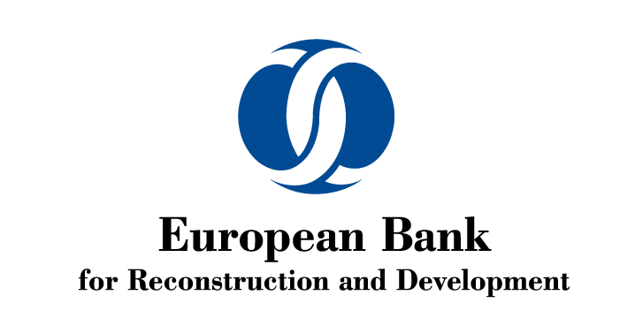
FOR IMMEDIATE RELEASE
 |  | www.ebrd.com/news | 
Date: 25-07-2016  Contact: Reiserer, Axel  Tel: +44 207 338 6741  Email: axel.reiserer@ebrd.com |  |  | Keywords: EBRD, Greece, Trade Facilitation Programme, Eurobank

The European Bank for Reconstruction and Development (EBRD) is supporting the expansion of international trade with a € 50 million facility to Eurobank under the EBRD’s Trade Facilitation Programme (TFP).
Strengthening trade is an important element of the EBRD strategy to support regional and global integration of the countries where it invests. Through integration economies can grow more strongly and sustainably as they successfully compete on global markets.
The facility will help Eurobank to scale up its trade finance activities, despite the financial market conditions, and - reaffirm itself as a prime trade partner, supporting trade activities of exporters, importers and distributors of imported goods in Greece.
Eurobank is one of Greece’s largest banks with a strong presence in the local and international banking market. The EBRD became a minority shareholder last year during the recapitalisation of Greece’s four systemic banks in order to strengthen their capital base and to facilitate their transfer into private ownership.
Nick Tesseyman, EBRD Managing Director for Financial Institutions, said: “We are pleased to sign this agreement with Eurobank today. It will boost intra-regional trade and contribute to the development of trade links between Greece and other countries, including those where EBRD invests. Supporting the expansion of trade finance in Greece is critically important for the revival of the country’s economy by creating opportunities for growth and job creation.”

Stavros Ioannou, Deputy CEO of Eurobank said that this agreement will have a multiplying effect for the Greek economy: “This significant deal comes in a very critical period for the Bank which is showing a recovery in its profitability and holds a position to assist the growth of the Greek economy. The deal is also important for the Greek economy itself, which has surpassed the difficulties of the past and is stabilizing in a rather difficult economic environment. EBRD has been a valued partner of Eurobank for many years and we have a long lasting cooperation that bears fruits for both organizations”.
The EBRD’s Trade Facilitation Programme, launched in 1999, aims to promote foreign trade to, from and among the countries where the EBRD invests.
Through the programme, the EBRD provides guarantees to international confirming banks and short-term loans to selected banks and factoring companies for on-lending to local exporters, importers and distributors.
The TFP currently includes over 120 partner banks in 25 countries where the EBRD invests, with limits exceeding €1.5 billion in total, and more than 800 confirming banks worldwide.
The EBRD started investing in Greece in 2015 on a temporary basis with the goal to support the country’s recovery from its current economic crisis. The Bank’s aim is to encourage foreign and domestic investment, strengthen the role of the private sector and deepen regional integration.

Facilitating trade relations is an important contribution to strengthen Greek banks’ and companies’ position in the international economy.
The EBRD’s strategic plan for the countries where it invests for the period 2016-18 has three priorities: strengthening economic resilience, addressing global challenges and supporting regional integration.

